Renewable Energy and Auctions in Latin America and the Caribbean

Renewable Energy Outlook
Latin America and the Caribbean (LAC) accounts for roughly 6% of global electricity generation, yet the region’s power sector stands out for its high reliance on clean energy (EMBER, 2025). The region has nonetheless had to serve a steadily expanding electricity system: final electricity consumption has risen consistently since 1970, with particularly strong expansion during the electrification push of the 1990s and early 2000s (Figure 1). As the system scaled up, the absolute increments required each year also increased—even as percentage growth moderated to about 2.4% in the 2010s—reaching much larger average annual additions in recent decades. This growing scale of demand provides the baseline for the region’s wind and solar expansion and for the procurement tools—especially auctions—used to contract new supply.
Figure 1. Electricity demand growth in Latin America and the Caribbean (1970-2024)
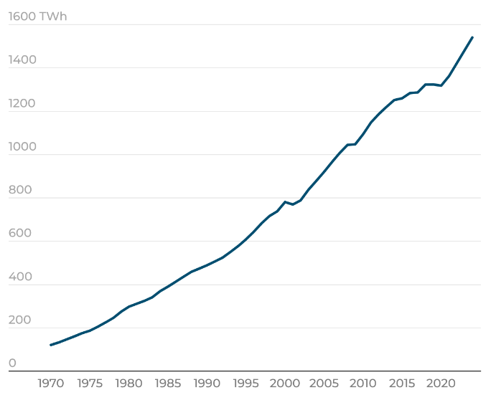 | 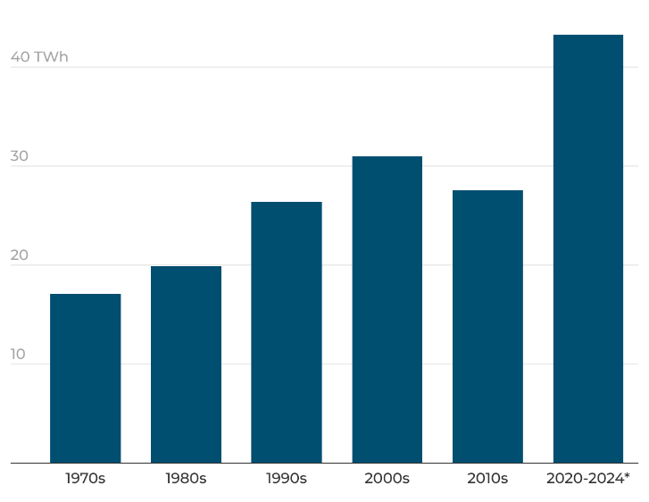
Source: Author’s elaboration base on data from OLACDE (2025).
Note: The left panel shows final electricity consumption in Latin America and the Caribbean from 1970 to 2024. The right panel shows the average annual increase in final electricity consumption by decade, computed as the mean of year-to-year changes (ΔTWh) within each decade. 2020–2024 is a partial-decade average.
While demand has grown, the composition of supply in LAC remains unusually clean by global standards. As of 2024, two-thirds of the region’s power generation comes from clean energy sources (OLACDE, 2025). This makes LAC the cleanest power sector of any global region, far above the ~30% global average (EMBER, 2025). However, this regional average masks substantial heterogeneity across countries. Some nations are virtually non-fossil-powered—such as Paraguay, Costa Rica, and Uruguay—routinely generating over 90–95% of their electricity from clean sources. In contrast, others remain fossil-fuel dominated, with negligible renewable output: Trinidad & Tobago’s grid is almost entirely natural-gas-based, The Bahamas relies on oil-fired generation, and Guyana continues to generate over 95% of its electricity from oil and diesel plants. This divergence underscores that while clean energy is increasingly central to the region’s electricity mix, each country’s path is unique (Figure 2).
Historically, hydropower has been the backbone of Latin America and the Caribbean’s electricity matrix. Around 41% of the region’s electricity supply still comes from hydro—by far the largest single source—and installed hydropower capacity is about 200 GW (OLACDE, 2025). Figure 2 shows how this legacy shapes today’s country outcomes: several systems with abundant hydro resources achieve very high clean generation shares (e.g., Paraguay, Costa Rica, Uruguay, and Brazil), while others remain dominated by fossil generation where hydro potential is limited or absent (e.g., Mexico, Trinidad & Tobago, Guyana). This heterogeneity underscores a central point for the region’s transition: expanding wind and solar is not only about increasing the clean share from an already-high baseline, but also about diversifying clean supply beyond hydro and creating viable pathways for countries whose clean backbone cannot be scaled primarily through large reservoirs.
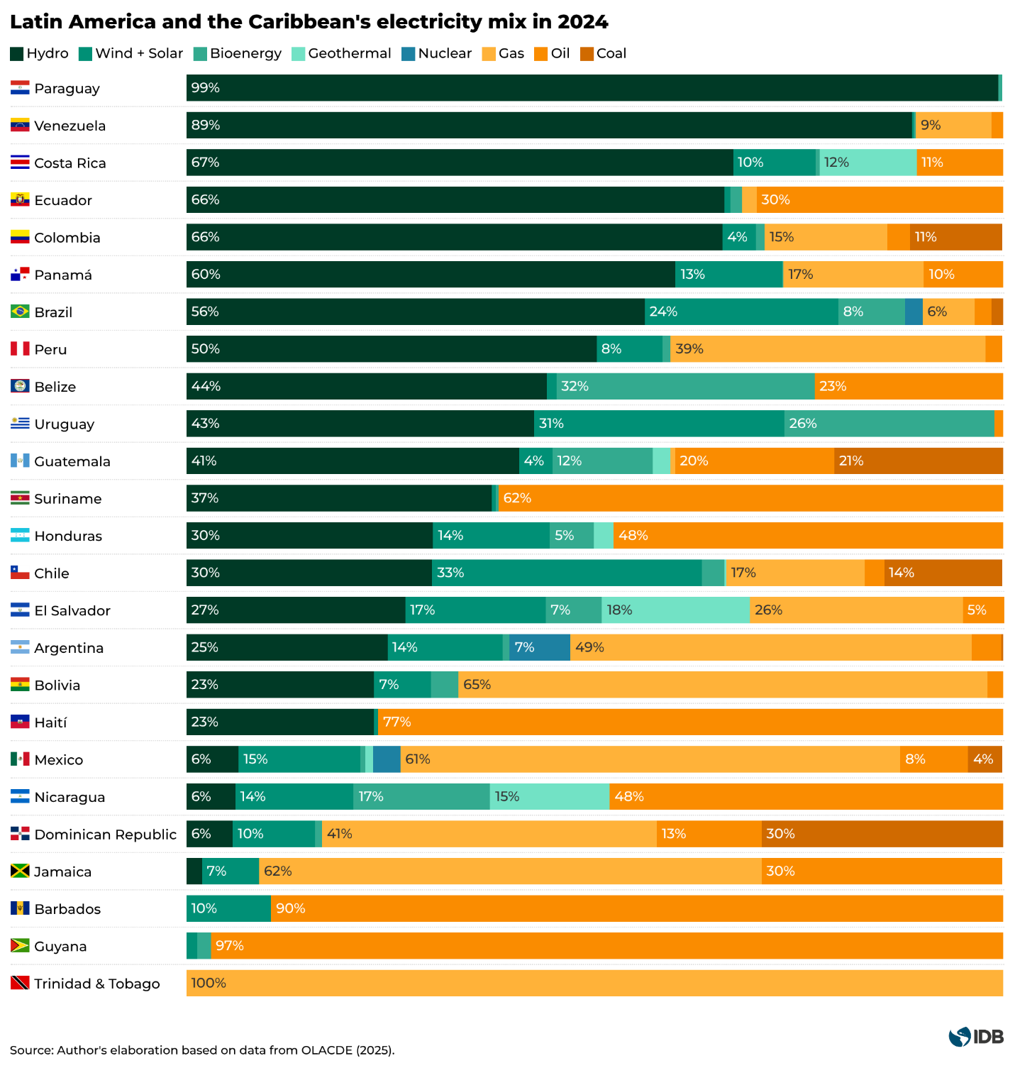
The boom of new technologies
Hydropower remains the single largest source of installed capacity in LAC, but its dominance has been progressively diluted as other technologies expanded faster. Total installed hydro capacity continued to rise—from roughly 138 GW in 2012 to about 201 GW in 2024—yet the pace of additions slowed markedly: the region added around 31 GW of hydro between 2012 and 2018, but only about 11 GW between 2018 and 2024 (OLACDE, 2024). Over the same period, wind and solar accelerated from a small base: wind and solar capacity reached roughly 130 GW by 2024, with most of the growth occurring after 2018—driven in particular by solar, which added about 71 GW from 2018 to 2024 (Figure 3). The implication is that hydro still grows in absolute terms, but it is no longer the main driver of system expansion; wind and solar increasingly account for the marginal additions that meet rising electricity needs.
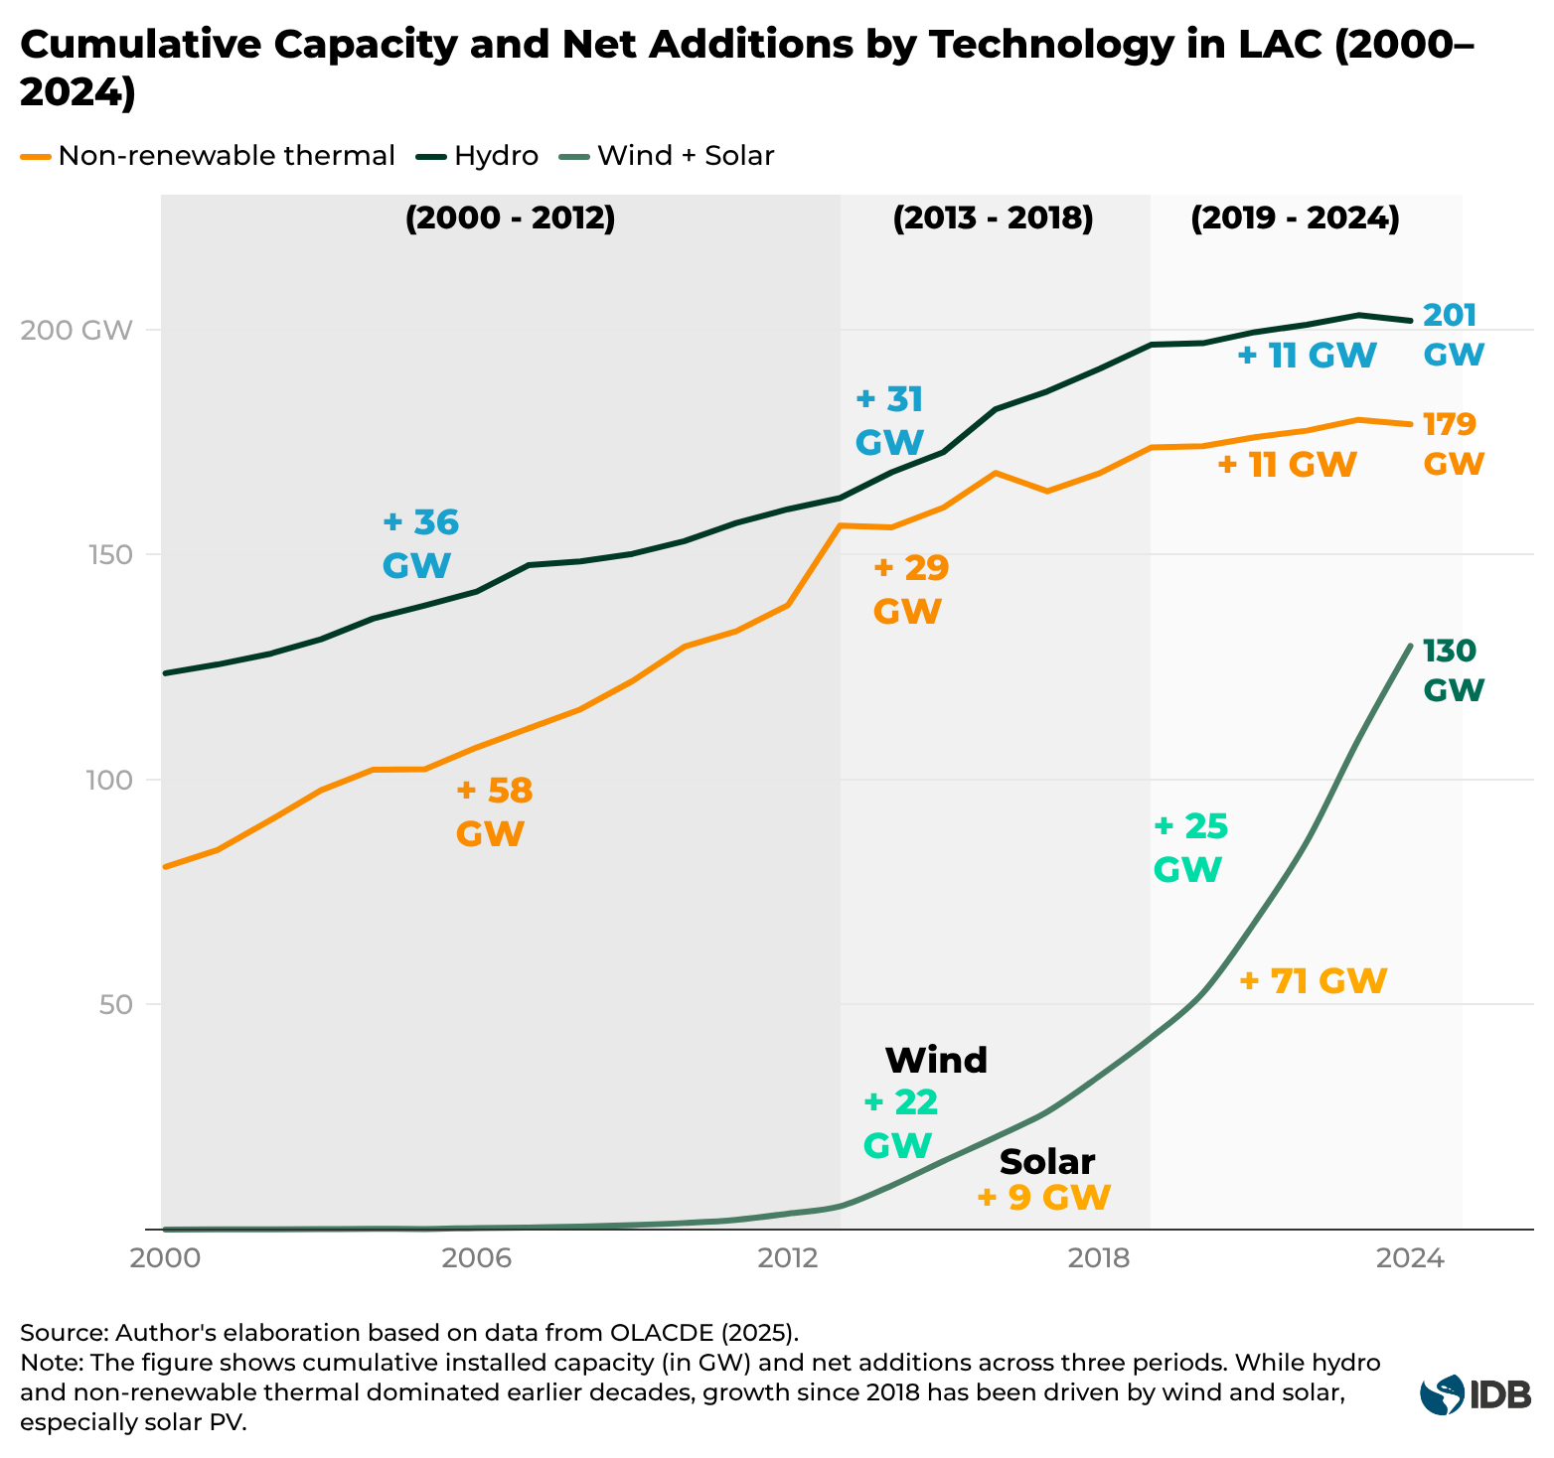
This shift in installed capacity is also reflected in the generation mix. Wind and solar increased from 2.7% of LAC electricity generation in 2015 to around 17% in 2024 (OLACDE, 2025). By contrast, fossil generation remains material: oil and coal together accounted for about 11% of generation in 2024, while natural gas continues to play a central role in several systems—notably Bolivia (~69%), Mexico (~61%), and Argentina (~49%)—where it remains the main source of electricity and an important provider of system flexibility (OLACDE, 2024). Overall, LAC’s transition is therefore not only about adding clean capacity, but about changing the marginal technologies that serve new demand while managing reliability constraints in systems that still depend heavily on thermal generation.
This rapid expansion has been uneven across countries. In installed-capacity terms, Brazil is now the regional anchor by sheer scale, accounting for roughly 62% of LAC wind-and-solar capacity, followed by Mexico (14%), Chile (11%), and Argentina (4%) (OLACDE, 2025). Brazil alone has around 78 GW of wind and solar installed (~53 GW solar and ~25 GW wind), and recent growth has been particularly solar-led: since 2022, installed solar capacity has reportedly increased at roughly ~1 GW per month (Source). These buildouts are increasingly visible in the generation mix: wind and solar provided about 24.5% of Brazil’s electricity in 2024, while Chile now has the region’s highest variable-renewables penetration, with wind and solar supplying roughly 33% of electricity and rising (Figure 4; OLACDE, 2025). Argentina’s late-2010s wind boom pushed wind and solar to about 14% of generation by 2024, and Mexico—despite a slowdown in new projects after 2018—still reached roughly 13.5% (OLACDE, 2025). Among smaller systems, Uruguay stands out: alongside a hydro- and biomass-heavy mix, it deployed roughly 1.5 GW of wind in a few years and, in strong-wind years, has achieved very high wind shares of demand (~40%).
Despite these gains, the region has likely only begun to tap its wind and solar endowments. LAC has world-class resources—from the steady winds of Patagonia and the Brazilian Northeast to the intense solar irradiance of the Atacama Desert and the Mexican Plateau (Source). Estimates suggest the region has realized only about 10% of its practical wind potential and 2% of its solar potential to date (Source). This implies substantial “headroom” for continued deployment, reinforced by high observed performance in prime zones—for example, solar PV capacity factors above 30% in northern Chile and onshore wind capacity factors of 40–50% in parts of Patagonia (Source). Policy ambition is also rising: RELAC, launched in 2019, has been signed by 16 countries, committing to 80% renewables share in electricity consumption by 2030 (Source).
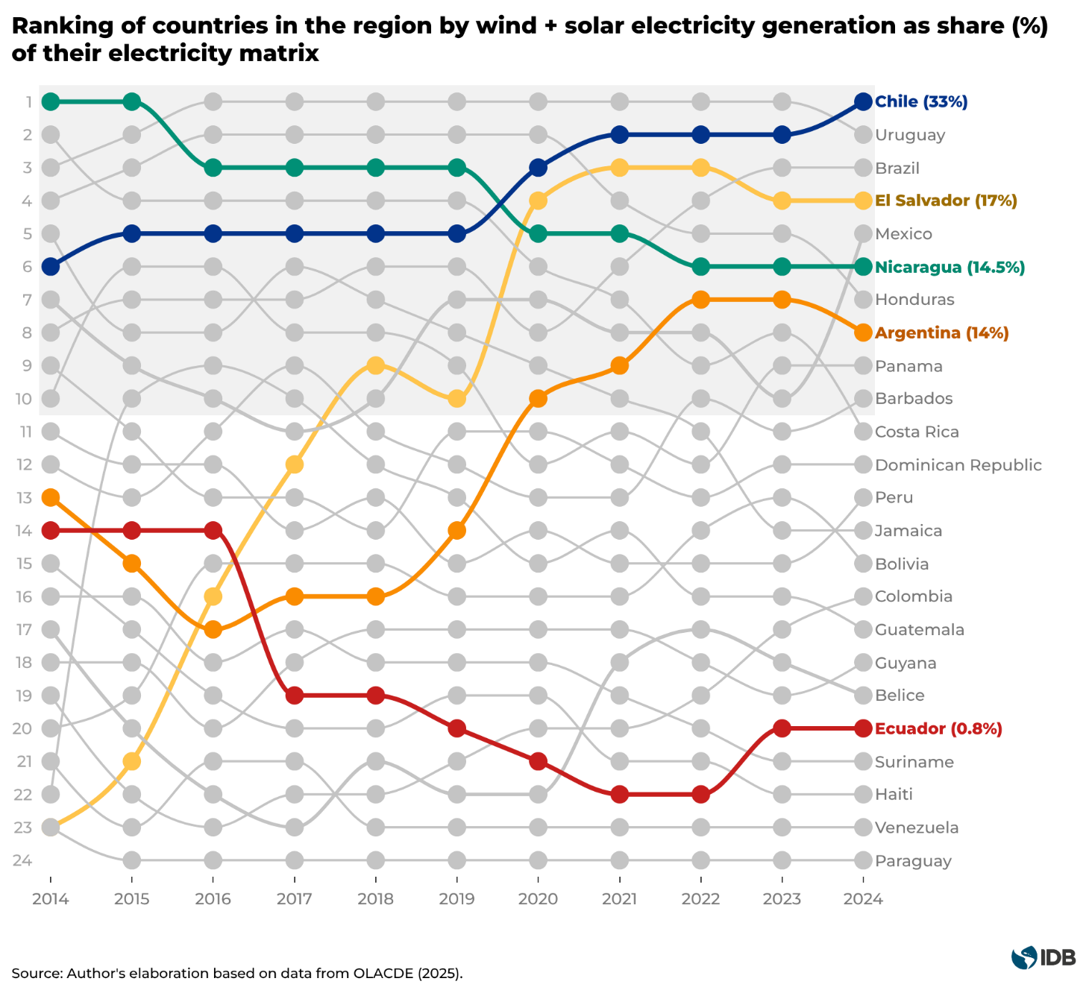
Tools of expansion
Two factors have enabled this transformation. First, the rapid growth of wind and solar has been underpinned by dramatic technology cost reductions driven in part by economies of scale, especially mass manufacturing in China, as well as mass adoption, steady efficiency improvements, and improved supply chains. In the last decade, unit costs of global renewables have declined at an impressive rate as adoption of these technologies has grown. As solar photovoltaic grew exponentially the IEA acknowledged it was “the cheapest electricity in history”, and onshore wind costs fell 70% from 2010, and is now less costly than new fossil fuel capacity in most regions with wind resources (IRENA, 2025). Solar PV module prices have plunged by over 90% since 2010 (Our World in Data, 2025). Energy storage prices have also come down fast, following a similar solar-modules-learning-rate drop, which bodes well for integrating more renewables (Ritchie, 2021). Lithium-ion battery packs used for grid storage and electric vehicles cost about $115 per kWh in 2024, a 20% drop just since 2023 and an 85% drop since 2013 (Source). This steep decline in battery costs is catalyzing the first wave of hybrid renewable energy projects in places like Chile and Brazil. For example, Chile’s AES, a power generation company, has announced a 1 GW battery energy storage system paired with 763 MW of solar, to help absorb daytime surplus and release it after dark (Source). Across LAC, dozens of battery projects are now planned or under construction to boost grid flexibility and reduce renewable curtailment.
Second, innovative demand-pull policy frameworks have increasingly reduced revenue risk and created bankable to market for renewables. Competitive procurement—especially auctions—has been a central tool in many countries; Section 2 provides a primer on auction design and shows how these mechanisms diffused globally and across LAC.
Dynamics of the system
As wind and solar expand, power systems must balance supply and demand in real time despite the variability of weather-driven generation—and they must do so while maintaining key grid-stability services (e.g., frequency and voltage control). In practice, this means that the operational challenge is often concentrated in a small number of hours: solar output rises sharply during the day and falls quickly in the late afternoon, while demand remains elevated. A standard way to make this dynamic visible is the net load, defined as system demand minus wind and solar generation. Net load approximates the portion of demand that must be met by dispatchable generation, storage discharge, imports, or other flexibility options.
A monthly operational snapshot for Chile (SEN) in November 2025, based on the Coordinador Electrico Nacional’s hourly demand and generation data, illustrates the scale of this balancing requirement (Figure X). Over the month, net load ranges from roughly 5.3 GW to 10.3 GW, with an average near 7.6 GW. The steepest operational stress emerges in the early evening: using a transparent metric (the change in net load between 17:00 and 20:00), the system faced an average ramp of about 3.8 GW over three hours (≈ 1.3 GW/hour), with peak days reaching roughly 5.2 GW over three hours. This ramp is mechanically linked to the late-afternoon decline in solar output: solar generation fell on average by about 4.8 GW between 16:00 and 20:00, with maximum drops around 5.4 GW. Peak demand occurs at 21:00, at about 9,760 MWh/h (≈ 9.76 GW).
Battery storage is observed to be contributing materially to short-run balancing. Battery operation is reflected in daytime charging and evening discharge—shifting energy across hours and providing fast response. In the 17:00-20:00 window, peak battery discharge averaged around 1.26 GW (with a maximum near 1.40 GW), and average discharged energy was approximately 2.7 GWh per day over that evening window. Incorporating storage operation into the net-load ramp metric (i.e., subtracting battery discharge and adding battery charging) reduces the average 17:00–20:00 ramp from about 3.8 GW to about 3.1 GW, a reduction of roughly 0.7 GW over three hours (~18%). The remaining ramp nonetheless remains large, consistent with the need for a portfolio of flexibility options—such as reservoir hydro dispatch where available, thermal ramping (often natural gas where it exists), internal redispatch and cross-border trade where interconnections permit, and continued expansion of storage and grid capacity.
Integration is therefore not a secondary issue: absent adequate measures for system flexibility and operational integration, up to 15% of solar PV and wind generation could be at risk of not being utilized or served in 2030, reflecting binding constraints such as curtailment, congestion, and insufficient flexibility (IEA, 2024). In LAC, the balancing challenge is shaped by a distinctive advantage—large shares of dispatchable hydropower with reservoir storage—but also by the fact that effective flexibility can tighten quickly during dry periods and in constrained grids.
[PLACEHOLDER—storage momentum anchor]
In practice, short-run balancing in many LAC systems is achieved through a portfolio of adjustments: (i) reservoir-hydro dispatch where available, (ii) thermal ramping—often natural gas where it exists—as a practical flexibility option, (iii) cross-border trade and internal redispatch where interconnections permit, (iv) curtailment when local congestion or inflexibility prevents absorption of renewables, and increasingly (v) battery storage, which can shift energy across hours and provide fast response services. A relevant operational nuance is that wind and solar are typically connected through power converters and do not provide by default the same stabilizing properties associated with synchronous machines; as variable renewables rise, frequency and voltage control can become more challenging unless system management and technical capabilities adapt (IEA, 2024, p. 20). This strengthens the case for system-friendly VRE deployment and contracting—i.e., planning, operating, or procuring wind and solar in ways that support system outcomes (for example, co-deploying wind and solar to leverage complementarity, using design choices that better match demand profiles, or siting projects to reduce congestion) (IEA, 2024, p. 38)—which provides a direct bridge to the procurement and auction design tools discussed in Section 2.
[PLACEHOLDER—LAC anchor on congestion/curtailment]
Absent adequate flexibility and network capacity, midday solar peaks can translate into higher curtailment and congestion risk (IEA, 2024).
How LAC systems are currently balancing rising wind and solar (role of reservoir hydro, thermal ramping, imports, curtailment, transmission constraints, and emerging storage), and why the balancing mix differs between hydro-dominant and thermal-dominant systems.
To provide an empirical, descriptive view of these operating patterns, we use monthly generation shares from Ember for 12 LAC countries from January 2018 to December 2025 to construct a descriptive, non-causal diagnostic of (i) wind and solar expansion, (ii) hydro variability, and (iii) short-run balancing response (Figure 5). While this exercise does not estimate causal impacts, it characterizes operational dynamics by quantifying the direction and magnitude of month-to-month substitution between hydro and thermal generation. Figure 5 can be read as follows: the x-axis (“backup slope”) summarizes how much thermal generation typically increases for a 1 percentage-point (pp) decline in hydro shar, while the y-axis (“backup response”) captures how consistently thermal moves opposite to hydro; points in the upper-right therefore indicate high and reliable thermal compensation during hydro shortfalls, whereas lower slopes and/or responses indicate a larger role for other adjustments channels (imports, demand variation, or non-thermal generation).
First, wind and solar penetration increased sharply in a subset of markets—most notably Chile (+24.9 pp), Brazil (+20.6 pp), Argentina (+15.5 pp) and El Salvador (+12.3 pp) in terms of the change in the 12-month rolling average share of generation—while gains were more modest elsewhere. Second, hydro remains a dominant source of volatility. Relative to a rolling 36-month hydro baseline, several systems experienced deep shortfalls, with worst “hydro swing” months reaching ~−21 to −27 pp (e.g., Ecuador −27.1 pp, Uruguay −24.3 pp, Costa Rica −24.0 pp), and repeated stress months in El Salvador (17), Peru (15), Brazil (13) and Ecuador (12). Third, short-run balancing often relies on thermal generation. In hydro-dependent systems such as Colombia, Peru, Ecuador and Bolivia, correlations approach −1 and slopes are near 1, consistent with near one-for-one thermal compensation during hydro shortfalls; in Mexico, Uruguay and El Salvador, lower slopes suggest a larger role for other adjustment channels.
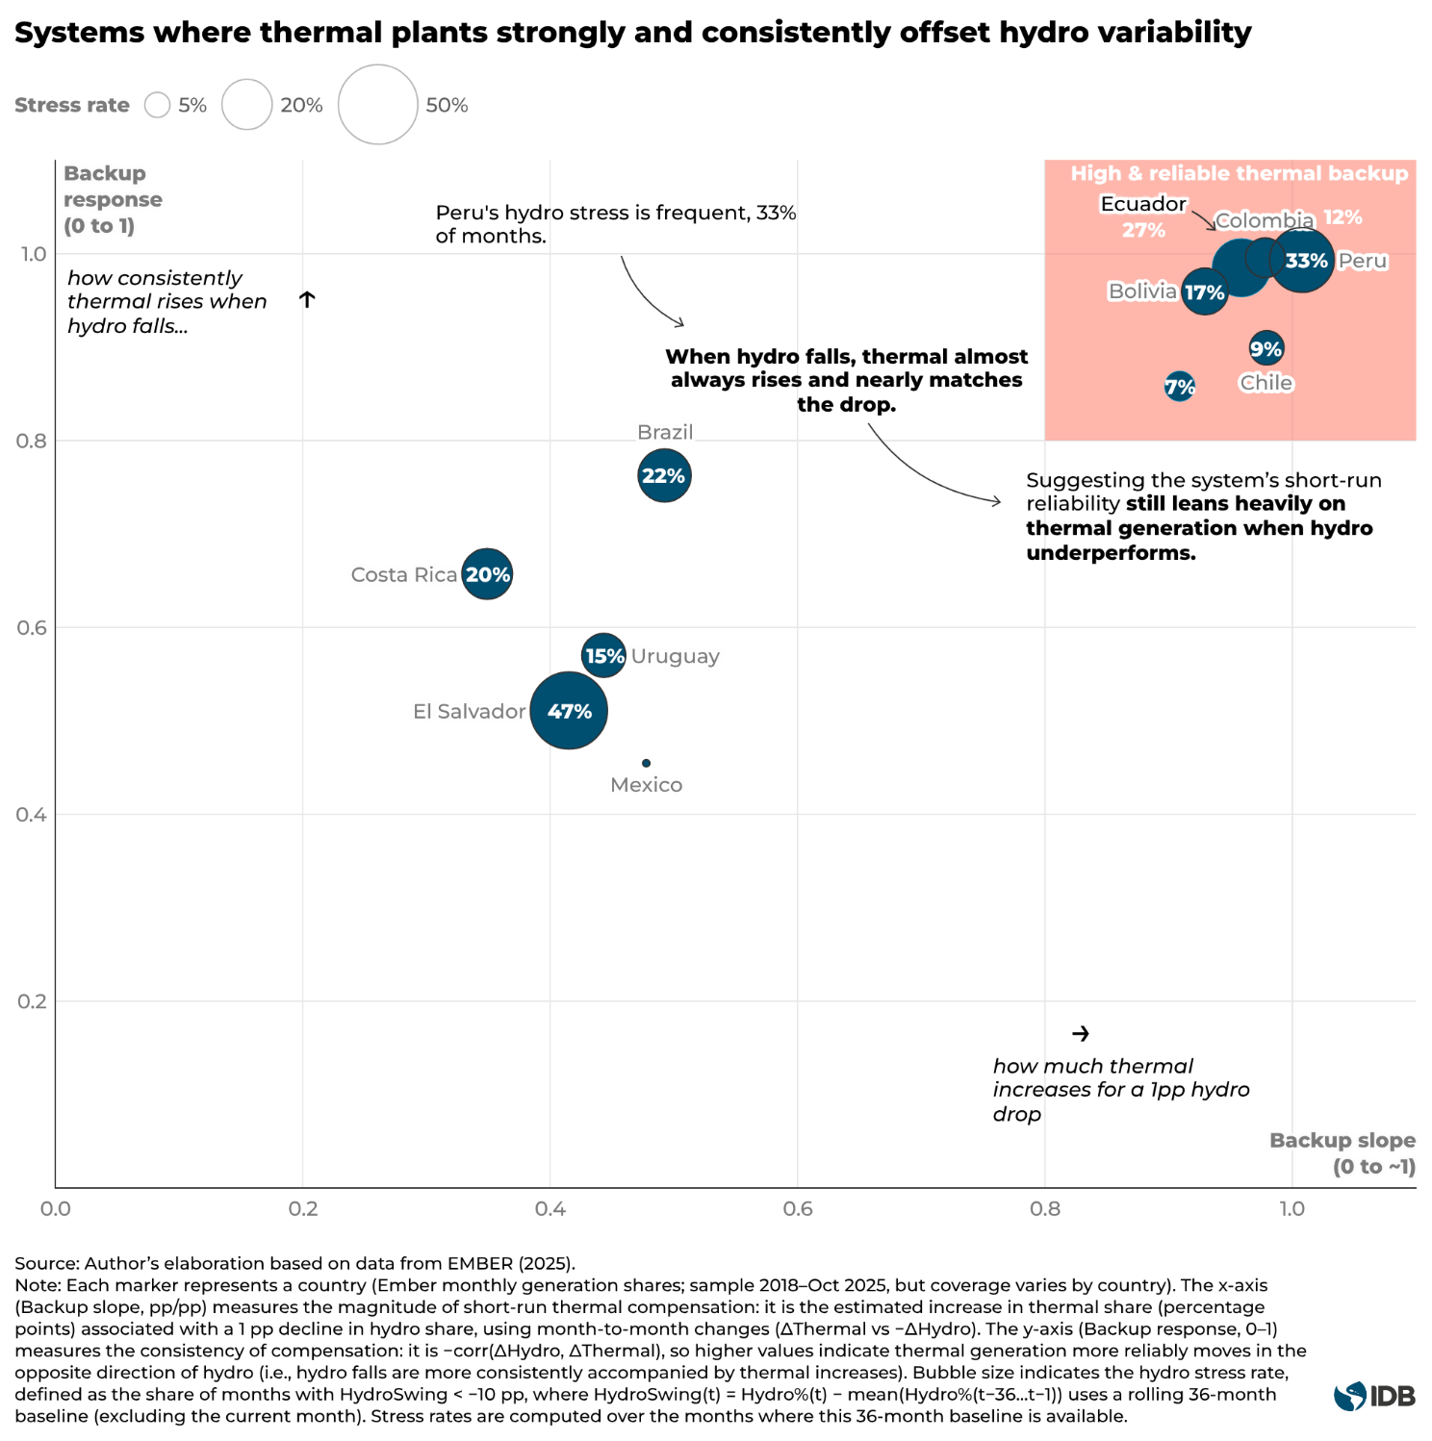 These descriptive patterns are consistent with causal evidence from Chile: using plant-level data (2000–2024), Bagnoli et al. (2025) find that local droughts reduce hydropower output by about 25% and trigger sharp increases in thermal generation among plants with spare capacity. Together, the evidence reinforces a key point for the region’s transition: hydro will remain a central flexibility resource, but increasing variability can translate into higher reliance on thermal balancing—often natural gas where it exists—unless complemented by grid upgrades, storage and other flexibility options, and by policy and procurement frameworks that sustain wind and solar deployment.
Structural challenges of hydro
Two structural challenges threaten the reliability and contribution of hydropower in LAC: increasing hydrological variability and aging infrastructure. Greater variability in precipitation affects water availability and therefore hydroelectric generation. In 2021, for example, Brazil experienced one of the most severe droughts in recent decades, causing a drop of more than 33 TWh in hydropower output, forcing the system to meet demand with more expensive and more polluting sources, such as gas and coal, and significantly increasing the dispatch of solar and wind generation (Source TBD). The opposite hydrological extreme can also matter operationally; years of exceptional inflows can temporarily boost hydro output and change the dispatch pattern (optional example; Source TBD).
Climate projections indicate uneven impacts: hydro plant capacity factors could decline sharply across Mexico, Central America, and the southern cone, with some locations seeing more than 30% output drops under high-emissions scenarios, whereas Andean countries such as Colombia, Ecuador, and Peru might experience slight increases in water availability (IEA, 2021). This dispersion implies that impacts will be highly system-specific, but it strengthens the case for resilience measures and complementary flexibility options in hydro-reliant systems.
Aging infrastructure adds a second constraint. LAC’s hydro fleet is relatively old—over 50% of installed hydropower capacity is over 30 years old (Source) (Figure X). Dozens of major dams built in the 1960s–1980s are at or beyond their design life; if not modernized, they can become a risk to security of supply. An estimated 2–3 GW of hydro capacity in the region reaches end-of-technical-life each year (Source). The IDB estimates modernization investment needs at around $33 billion this decade just to upgrade 60 GW of aging hydro facilities (Source). This includes replacing equipment and adapting plants to new operating conditions, handling more variable inflows and providing faster ramping to complement wind and solar. Overall, while hydropower will remain the bedrock of LAC’s power system, strategic investments are needed to climate-proof and modernize this backbone.

Energy Auctions

Auction Primer
What is an energy auction
Energy auctions, also referred to as competitive tenders, are a structured way for governments, regulators, or mandated buyers to procure electricity supply and/or capacity from private developers through competition under pre-defined rules. In most clean-energy contexts, the auction allocates the right to sign a standardized long-term contract (often a power purchase agreement, PPA, and sometimes a contract-for-difference style arrangement) to the lowest-priced qualified offers, sometimes with additional criteria beyond price. The core policy rationale is simple: auctions can reveal prices through competition while providing the long-term revenue certainty that capital-intensive renewable projects typically need to reach financial close (IRENA, 2015; del Río, 2017; Haufe and Ehrhart, 2018). In Latin America and the Caribbean, auctions have been widely used to mobilize private investment and scale non-conventional renewables, with countries adapting the mechanism to different market structures and policy objectives (e.g., centralized single buyers, liberalized markets with distribution-company procurement, or hybrid arrangements) (Viscidi and Yépez, 2020).
Who’s who and what gets signed
An auction is easiest to understand by separating the roles and the legal instrument that comes out of the process. The auctioneer is the entity that designs and runs the procurement (often a ministry, regulator, system operator, or a procurement agency acting under a legal mandate). The bidders are project developers competing to win a contract. The offtaker is the party that ultimately pays for the contracted output—commonly a state-owned utility, a system/market operator acting as buyer-of-record, or distribution companies procuring on behalf of regulated consumers.
The output of the auction is a contract that specifies (i) what is being purchased (the “product”), (ii) for how long (tenor), (iii) under what price and settlement rule, and (iv) how performance, payment, and risk are handled (IRENA, 2015). The awarded price is therefore a contracted remuneration parameter—often a strike price, indexed price, or bid price—rather than a wholesale “spot price”. Confusing these can lead to misinterpretation: spot prices are short-term contractual outcomes; auction prices are long-term contractual outcomes whose level depends not only on technology costs, but also on risk allocation, bankability, and competition conditions (IRENA, 2026).
What is being procured—and why it matters for prices
The first technical building block is the product definition, because it determines what the bidder must deliver (physically or financially) and what revenue certainty the contract provides. Some auctions procure energy—a commitment tied to electricity delivered or deemed delivered, typically measured in MWh. Others procure capacity—a commitment tied to installed capability, typically measured in MW, sometimes paired with availability requirements. Still others include attribute products, such as renewable energy certificates or clean energy certificates, which either (a) add a separate revenue stream or (b) are bundled into the procurement so bidders prices them into their offers. These distinctions matter because they change which risks the developer must manage and therefore what risk premium is embedded in bids. For example, energy-oriented products can shift more exposure to production profile and market outcomes while still requiring the project to be built and available (Hochberg, 2018).
In Mexico’s long-term auctions, bidders competed across multiple products (including energy, capacity, and certificates), which changes both the revenue stack and the way developers optimize bids. In Chile, auctioned supply obligations can be defined in time blocks, which effectively prices the “shape” of delivery and changes which technologies are advantages in different hours and seasons. The key point is not the country detail, but the general lesson: different products imply different risks, and different risks show up in the auction price (Viscidi and Yépez, 2020).
Auction format and pricing rule—and how they shape bidding
Auctions also differ in format and pricing rule, both of which affect bidding strategy and observed prices. In a sealed-bid auction, bidders submit one (or a limited number of) confidential offers without seeing competitors’ bids. In a dynamic auction, prices adjust through multiple rounds and bidders react to evolving information (for example, clock auctions where the price ticks down and bidders remain in or drop out). Format matters because it changes price discovery (how much bidders learn during the process), the scope for strategic behavior, and the risk of overly aggressive bids that later fail to deliver.
The pricing rule determines what winners are paid. Under pay-as-bid, each winner receives its own bid price. Under a uniform (market-clearing) price, all winners receive the same price set by the marginal accepted offer. These rules can yield different bidding incentives and different dispersion in observed prices, even when underlying project costs are similar. The broader auction-design literature emphasizes that such implementation choice can materially affect outcomes, and that “best practice” design often requires balancing price objectives with delivery and credibility objectives (IRENA, 2026).
Brazil has used designs that combine elements across pphases (including mechanisms that intensify price competition during the process), which highlights the general point that format choices are not cosmetic—they alter the competitive dynamic bidders face.
Contract terms that drive bids
The most important “toolkit” concept for interpreting auction prices is that bids are not only a function of equipment and construction costs; they are also a price for bearing risk under enforceable contract terms. IRENA’s recent framework emphasizes that auction design is, in practice, a set of choices about risk allocation—who bears which risk, under what remedies, and with what credibility—and that these choices affect both achieved prices and realization outcomes.
Risk allocation refers to “who bears what” among developers, offtakers, and the public sector. A few risk categories dominate bidding behavior.
Market/price risk concerns exposure to wholesale electricity prices after the auction. A fixed-price PPA largely insulates the project from spot prices (supporting bankability), while more market-linked arrangements—such as premium-based schemes or certain CfD-like structures—expose the project to market revenues with an offsetting settlement. In general, the more revenue uncertainty the developer bears, the more bids must compensate investors for that uncertainty, all else equal.
Volume and shape risk concerns whether the seller must match a delivery profile (for example, supplying specific time blocks) rather than simply producing when the resource is available. When a contract requires delivery in defined hours, intermittent generators may need forecasting, balancing services, storage, or contractual hedges; these costs and risks are priced into bids. Time-differentiated obligations can improve system value alignment, but they also make “the product” more complex and therefore affect observed auction prices (IRENA, 2019).
Construction and delivery risk concerns completion deadlines, permitting status, milestones schedules, and the consequences of delay. If delays trigger material penalties or termination, bidders will price a higher risk premium unless risks are mitigated through realistic timelines and credible, transparent permitting and grid-connection processes (IRENA, 2026).

Global Analysis
One of the most influential policy tools behind LAC’s renewable energy surge has been the use of competitive energy auctions. Over the last 20 years, auctions have become the dominant global method for procuring renewable energy, with 96 countries having launched a clean energy auction by 2022– and LAC countries have been at the forefront of this trend (Eberhard and Kruger, 2023). According to BloombergNEF data, 1,817 clean energy auction rounds have been completed globally between 2004 and 2024, contracting around 1,300 GW of clean energy capacity across more than one hundred countries (Source). To put this into context, the capacity allocated through clean energy auctions over this period is equivalent to roughly 14% of total global installed generation capacity (renewable and non-renewable), comparable in scale to the total installed capacity of the United States (Source).
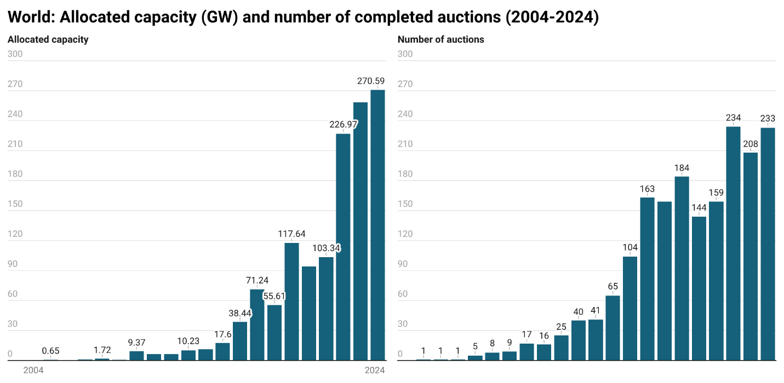
Source: Author’s elaboration based on data from BNEF (2025).
Globally, competitive clean energy auctions expand sharply after the mid-2010s, with both the number of completed rounds and allocated capacity accelerating and remaining high through the early-2020s. The volume series becomes increasingly dominated by large procurement years, indicating that global auction activity is not just more frequent but also concentrated in bigger rounds. Even when the number of rounds plateaus slightly year-to-year, allocated capacity remains elevated, suggesting that scale per round has increased over time. In 2024 alone, 270 GW of clean energy capacity was allocated through auction rounds.
Clean energy auctions are heavily concentrated geographically: three markets accounted for eight out of every ten MW of capacity allocated worldwide. China alone has awarded 559 GW—over 40% of all auctioned capacity globally, even surpassing the total 540 GW of solar installed worldwide in 2024 (Source). Europe followed with 300 GW (23%), while India allocated 206 GW, driven primarily by solar PV projects. Latin America and the Caribbean allocated nearly 62 GW.
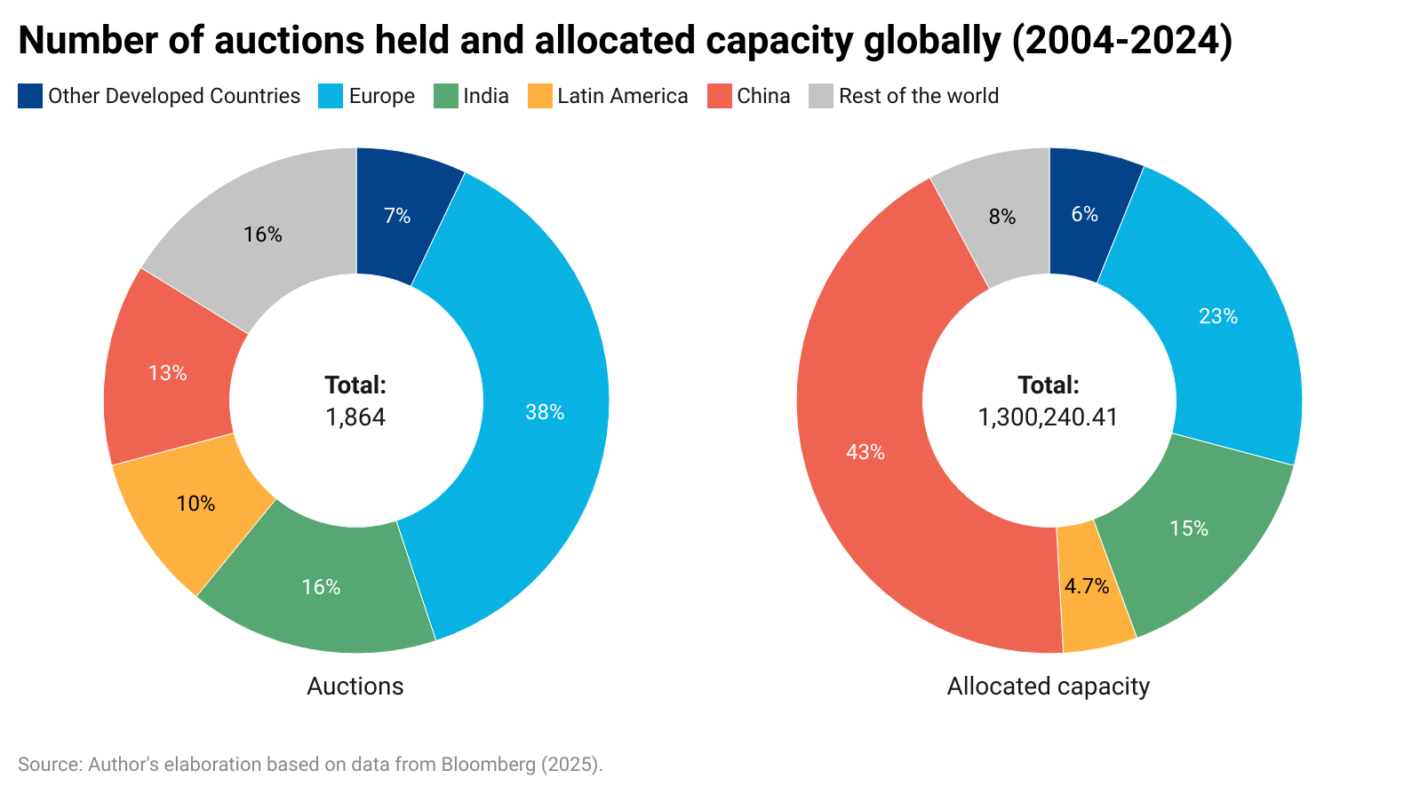
Figure X benchmarks Latin America and the Caribbean’s auction footprint against global activity by comparing, for each year, LAC’s share of completed auction rounds with its share of allocated capacity (MW). Two patterns stand out over 2014-2024. First, during 2014-2016, LAC’s allocated-capacity share is materially higher than its rounds share, indicating the region’s global presence was driven by fewer, larger rounds relative to the world average. Second, from 2017 onward the relationship flips: LAC’s share of rounds is generally above its share of allocated MW, consistent with a shift toward more frequent but smaller procurement rounds relative to global leaders. In short, LAC runs roughly 1 in 10 global auction rounds but delivers about 1 in 20 global auctioned MW.
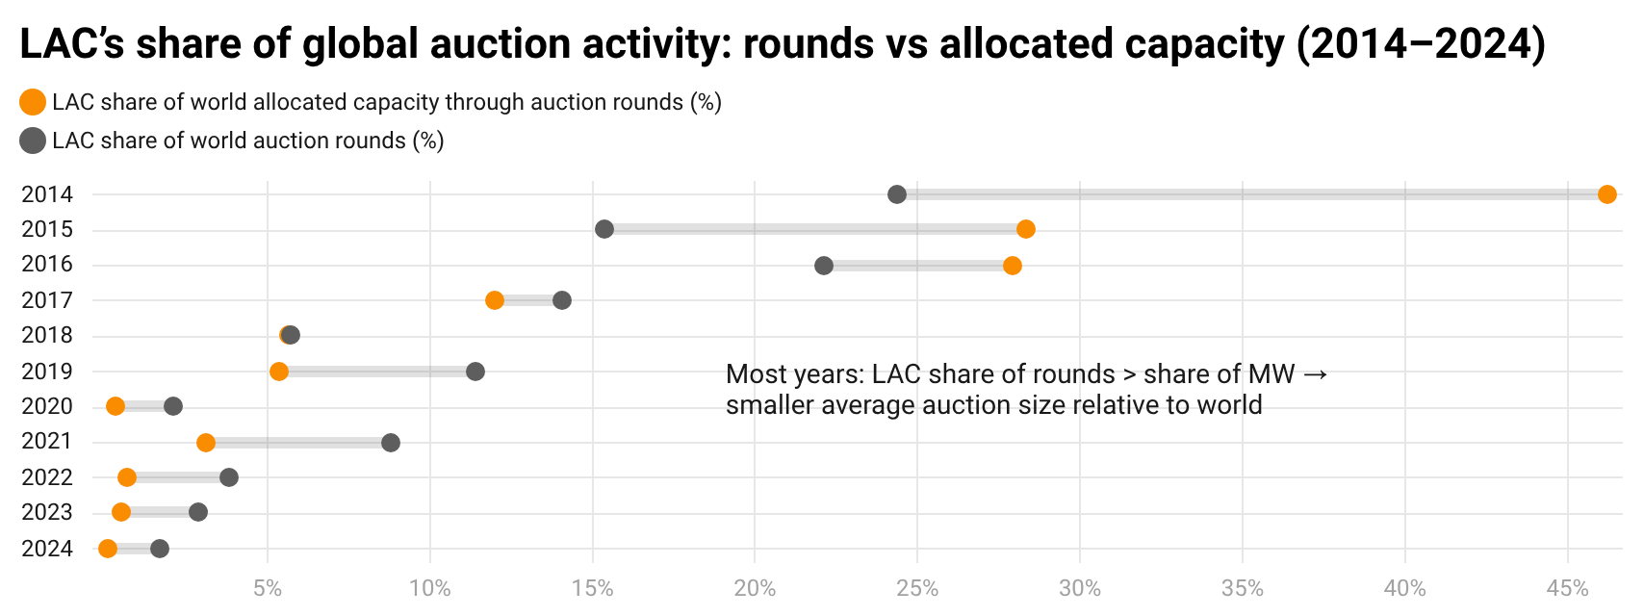
Source: Author’s elaboration base on data from BNEF (2025).
Note: Each year shows Latin America and the Caribbean’s share of global completed auction rounds (gray) and allocated capacity (orange). The connecting line highlights the gap between these shares; when the rounds share exceeds the capacity share, LAC’s average auction size (MW per round) is smaller than the global average for that year. Early years (pre-2014) are excluded because global auction volumes were still small, producing mechanically volatile shares and outliers that obscure the more stable pattern in recent years.
LAC’s auction cycle is comparatively episodic. Allocated volumes peak around 2016 (10.7 GW), while the number of completed rounds peaks around 2016–2017 (23 rounds), after which annual allocations become smaller and more irregular (Figure W). This combination—bursts of activity and a post-2017 shift toward smaller rounds—helps explain why LAC can be relatively active by count while contributing a smaller share of global auctioned MW.
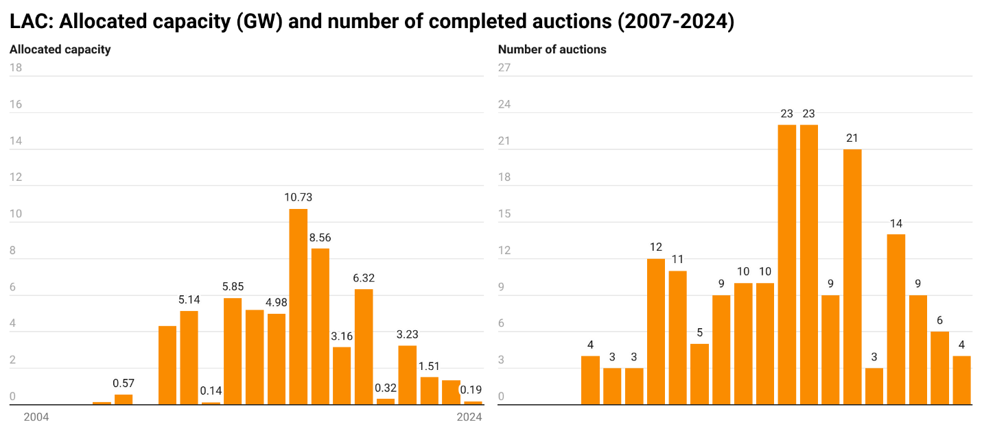
Source: Author’s elaboration based on data from BNEF (2025).
In terms of technologies, solar dominates the auction landscape in the dataset, with 676 GW of capacity allocated through completed auction rounds over 2004–2024—just over half of total auctioned capacity. Wind follows with 409 GW (onshore and offshore combined), making it the second-largest technology. Together, solar and wind account for the bulk of auctioned volumes; expressed relative to the global generation fleet, auctioned solar in the dataset is equivalent to roughly ~7% of total installed capacity worldwide, and auctioned wind to ~4–5% (IRENA, 2025).
Beyond solar and wind, volumes are smaller but non-negligible: 136 GW are recorded under storage-backed/multi-tech, while standalone storage accounts for 11 GW. Data suggests a recent structural shift toward hybrid procurement: storage-backed/multi-tech allocations rose from 7.2 GW in 2023 to 116.8 GW in 2024 (+109.6 GW), accounting for ~43% of all global auctioned capacity in 2024—offsetting a simultaneous decline in standalone solar and wind volumes and keeping total auctioned capacity elevated.
The remaining 67 GW fall under other clean sources, including a distinct “unknown technology” component. Because some auction rounds are technology-neutral and may not be tagged by technology in the database, the “unknown technology” category should be interpreted as a classification gap and may include unclassified solar and wind awards rather than fundamentally different technologies.
Figure X. World allocated capacity through clean energy auctions
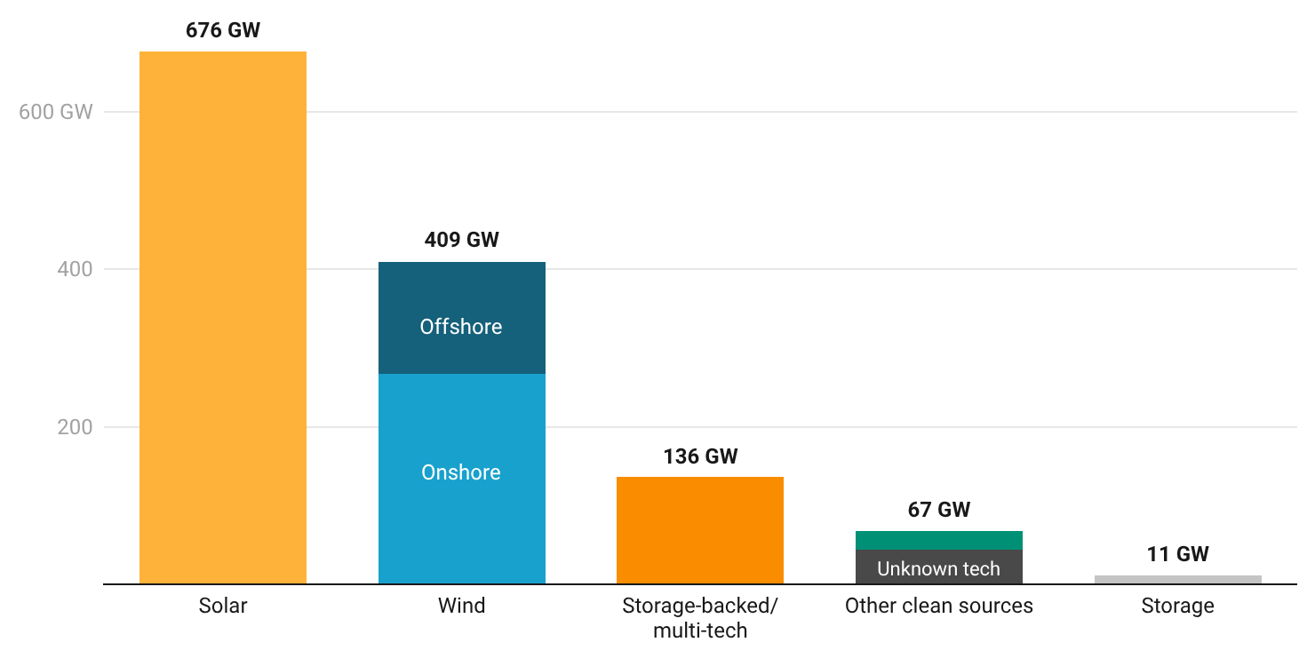
Source: Author’s elaboration based on data from BNEF (2025).
Note: Values show allocated capacity (GW) from completed auctions (2004–2024) in the BNEF dataset. Categories are mutually exclusive: records labelled as multi-technology (e.g., “solar and storage,” “wind and storage,” “solar and wind,” “solar and wind and storage”) are reported under Storage-backed/multi-tech (orange) and are not included in the standalone Solar or Wind totals. Storage (light gray) includes auctions explicitly labelled battery storage or other storage (standalone). Other clean sources aggregates non-wind/solar technologies like hydro, geothermal, bioenergy (green) and “unknown tech” (dark gray) indicates the underlying clean technology is not specified in the source; it is shown separately within the “other” grouping to distinguish classification uncertainty from identified technologies.
Over 2004-2024, wind (26.9 GW) and solar (17.2 GW) account for roughly ~72% of auction-awarded capacity in LAC (Figure X). This mirrors the global picture—where solar and wind dominate total allocations—but LAC tilts more strongly toward wind and shows much smaller volumes of storage-backed/multi-tech awards (only ~0.2 GW in LAC versus a material multi-tech/storage-backed segment globally). While the global auction landscape increasingly records hybrid and storage-backed procurement, LAC’s auction outcomes in this dataset remain primarily a wind-solar deployment mechanism, with limited evidence of a comparable scale-up of storage-linked awards to date. The “unknown technology” component is driven primarily by Chile (about 7.1 GW, ~80% of LAC unknown tech), consistent with technology-neutral rounds where awards are recorded without a technology tag.
Figure X. LAC allocated capacity through clean energy auctions
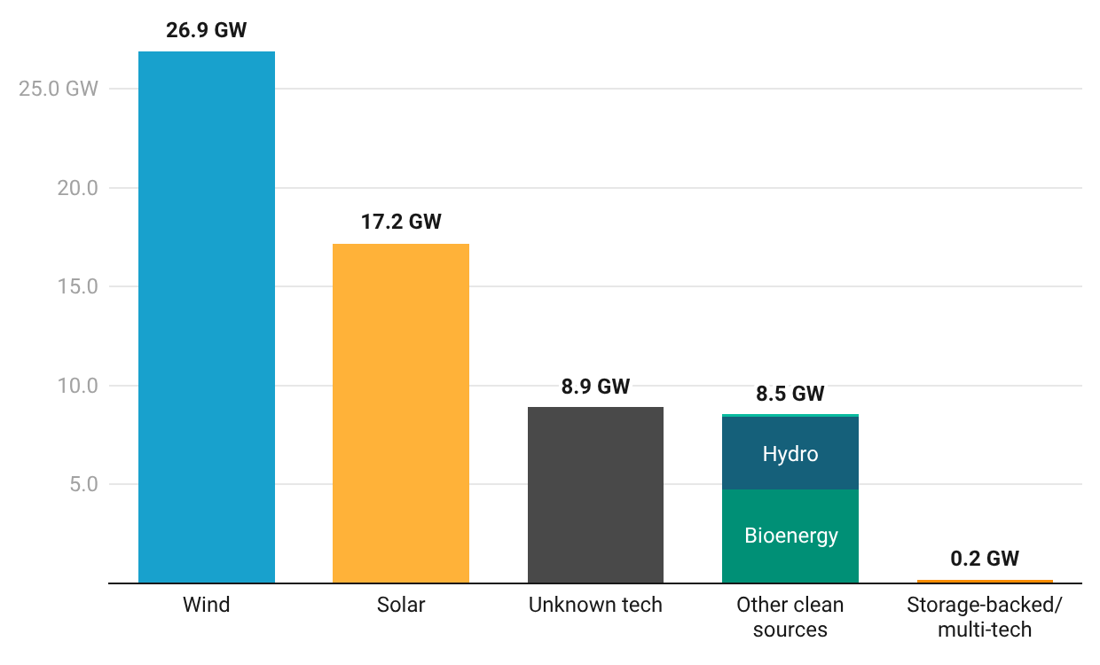
Source: Author’s elaboration based on data from BNEF (2025).
To assess auction outcomes in price terms, we use BNEF’s recorded average price (US dollars per megawatt-hour, USD/MWh), restricting the sample, again, to completed auctions between 2004 and 2024. This price metric is reported in a common currency and unit, enabling consistent comparisons across regions. From the initial universe of 1,864 completed auction entries, 359 observations (19%) do not report a USD/MWh value and are excluded from the price analysis, leaving 1,505 price observations globally (and 174 in LAC, from 186 initially). Because price coverage and comparability vary substantially by technology, the core analysis focuses on solar and wind, which account for most priced observations and provide the only sufficiently dense time series to support distributional analysis; other technologies (e.g., storage-backed/multi-tech, hydro, bioenergy) are either sparse or heterogeneous in pricing conventions. Furthermore, since early years contain very few observations and can be dominated by idiosyncratic values, annual statistics are reported only where sample sizes are adequate: we show medians and interquartile ranges (IQR) when annual counts are N≥20, medians only when 10≤N<20, and we do not report annual statistics when N<10. On this basis, global solar price trends are presented from 2014 onward, and wind from 2015 onward.
Globally, auction-clearing prices for both solar and wind fall markedly over the last decade, but they do so with distinct trajectories in both level and dispersion (Figures X-X). Data shows a strong “early compression” dynamic for solar, and a more cyclic and heterogeneous pattern for wind.
Solar prices exhibit a steep downward adjustment followed by a lower-price plateau. In the mid-2010s, the median solar price was still very high, reflecting early market development and heterogeneous procurement context; by 2014, the median sits around $140/MWh, and then declines rapidly through 2015-2018. By the late 2010s, the median stabilizes near the $50/MWh range, reaching a trough around 2019 (~$51/MWh). In 2024, the global solar median remains close to this lower band at roughly $53/MWh, indicating that the largest part of the global price reduction occurred during the scaling phase of the mid-to-late 2010s rather than through steady declines thereafter. Dispersion reinforces this story: the IQR is wide in the early years of the reporting window—then narrows as the market matures and prices converge, and widens again around 2020–2021, suggesting renewed heterogeneity across jurisdictions and contract terms. By 2024, the spread is substantial (IQR roughly $32–$82/MWh), underscoring that even within the “mature” phase, auction outcomes span a broad range depending on local fundamentals and design features.
Figure X. Global solar auction prices (median and interquartile range), 2014–2024
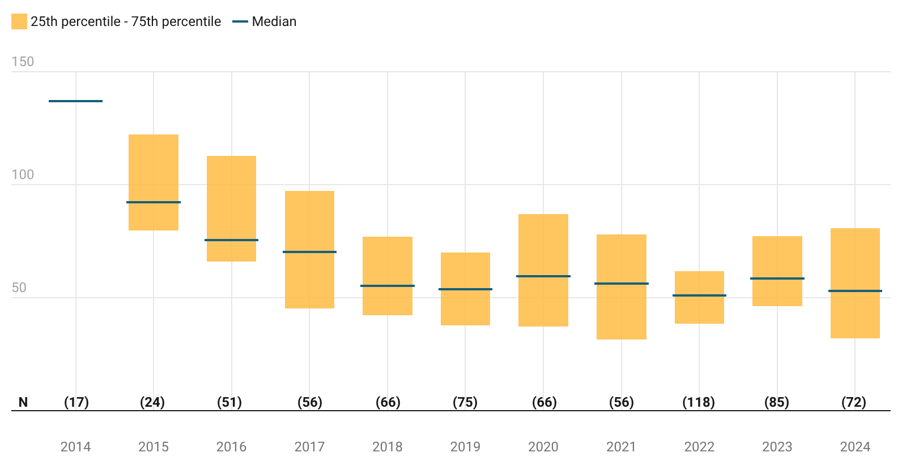
Source: Author’s elaboration based on data from BNEF (2025).
Note: Values show annual distributions of PV auction prices (USD/MWh) from completed auctions in the BNEF dataset (core sample excludes prices <$1/MWh). The figure reports the median and interquartile range (25th–75th percentile); IQR is shown only when N≥20 (median only when 10≤N<20). To ensure a consistent technology series, the PV sample excludes non-PV solar categories such as solar thermal/CSP and agrivoltaics, which have different cost structures and appear sparsely in the price data.
Wind results are presented for onshore separately; offshore wind auctions are fewer and follow a different cost profile, so pooling can obscure the underlying pattern. Onshore wind prices behave differently from PV. Wind starts with medians around $60/MWh in 2015. After 2017, the median rise steadily, peaking in 2020 at $67-MWh. This mid-period increase is also accompanied by relatively tight dispersion in 2020 where IQR’s spread is $16/MWh, suggesting that outcomes were not only higher but also more clustered in that year. Wind then shifts downward, the median reaching a trough around $42/MWh in 2022, the year with more energy auction entries (N=49), before reversing again. In the most recent years, wind prices rebound strongly: median Wind starts with medians around $60/MWh in 2015 (N=10) and $57/MWh in 2016 (N=11).
Figure X. Global wind auction prices (median and interquartile range), 2015-2024
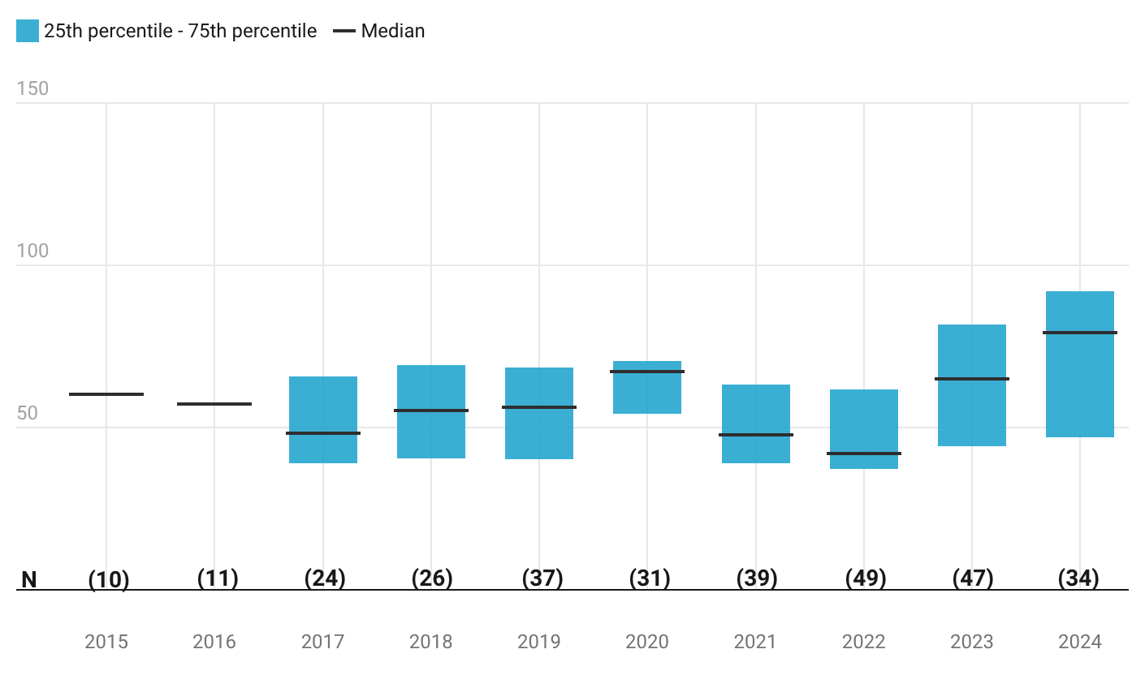
Source: Author’s elaboration based on data from BNEF (2025).
Note: Values show annual distributions of onshore wind auction prices (USD/MWh) from completed auctions in the BNEF dataset (core sample excludes prices <$1/MWh). The figure reports the median and interquartile range (25th–75th percentile); IQR is shown only when N≥20 (median only when 10≤N<20). To avoid pooling distinct technologies, the wind sample excludes offshore wind and floating offshore wind, whose cost profiles and contracting conditions differ materially from onshore wind and can distort pooled trends.
The joint movement —higher medians plus widening IQR in 2023–2024—seen also in solar is consistent with a more heterogeneous cost and risk environment in recent procurement cycles. It is plausible that economy-wide factors, notably post-pandemic cost environment, financing conditions, and inflation, contributed to higher clearing prices (Sources).
To benchmark regional prices outcomes in a way that remains comparable across heterogeneous auction designs, we extend the global analysis with a period-based regional comparison focused on solar PV and onshore wind. Annual regional series are too sparse —particularly in LAC—to support robust distributional reporting using the same thresholds applied in the global time series. Instead, auctions were pooled into four multi-year buckets to summarize outcomes using the median awarded price for a combined PV and onshore wind “basket”.
A key interpretative challenge is that pooled PV+wind medians can move due to changes in price levels within each technology, but also due to shifts in the regional composition of procured capacity between PV and wind. To make this explicit, Figure X overlays each region’s observed median with a mix-matched global benchmark. The benchmark answers a narrow question: given the region’s PV versus wind allocation mix (by MW) in a given period, what median price level would be implied by global PV and global wind median in that same period?
By construction, this comparator controls only for PV/wind composition; remaining gaps should be interpreted descriptively as reflecting differences beyond technology mix, such as contract structures, local market conditions, design features, without implying causality.
Three patterns stand out. First, Europe’s observed medians remain consistently above the mix-matched global benchmark across periods, indicating that Europe’s higher pooled outcomes are not explained by PV/wind composition alone. A plausible interpretation is that European auction outcomes embed design and risk-allocation choices that can raise bid levels even when underlying technology costs are low. Auction design is, in practice, a risk-allocation mechanism—shaping who bears market risk, what delivery obligations apply, and whether objectives beyond price are embedded in award rules (IRENA, 2026). In Europe, this is visible in both remuneration approaches (including CfD-type arrangements in liberalized markets and premium-based schemes that shift market exposure to bidders) and in a growing role for non-price criteria under evolving European rules. Consistent with these channels, empirical evidence from Europe shows that awarded prices vary systematically with design elements (e.g., ceiling prices, project-size restrictions, quotas) and competition intensity (Anatolitis et al., 2022). (Fleck & Anatolitis, 2023)
but rather risk allocation, contract structure, and auction rules can increase prices (IRENA, 2026). For example, design features meant to protect certain bidder types or project categories can affect realization risk and bid strategies, which impact prices,
Second, India and LAC lie below the mix-matched benchmark in the periods where reporting thresholds are met, consistent with lower awarded prices relative to global PV/wind reference levels given their allocation mix. Well-designed auctions Academic work in Indian solar auctions highlights how auctioning contributed to substantial price declines (Thapar et al., 2018). For LAC, the below-benchmark gap is most pronounced in 2019–21, when the regional median drops sharply relative to earlier periods; while this comparison does not identify drivers, the magnitude of the dip suggests a material shift in observed auction outcomes rather than a simple artifact of changing PV/wind shares.
Third, China exhibits a distinct transition: the median is high relative to the benchmark in 2016–18 ($112 vs $69) but converges to around—or slightly below—the benchmark in later periods ($49 vs $55 in 2022–24). China’s convergence toward the mix-matched benchmark after 2019 is consistent with a broader shift from fixed support regimes toward more competitive and market-oriented mechanisms, alongside massive scale and learning effects that pushed technology costs down and subsidy burdens became harder to sustain (Roberts, 2020; Zhang et al., 2025).
Figure X.
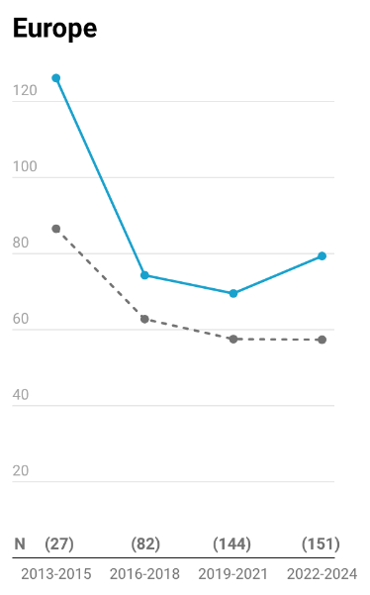 | 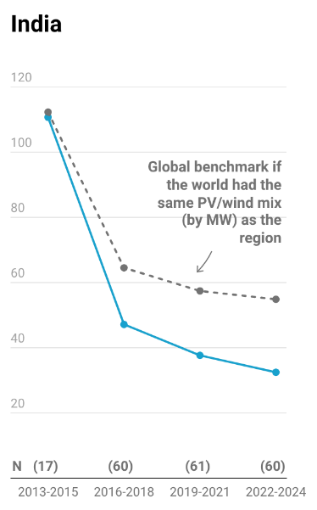 | 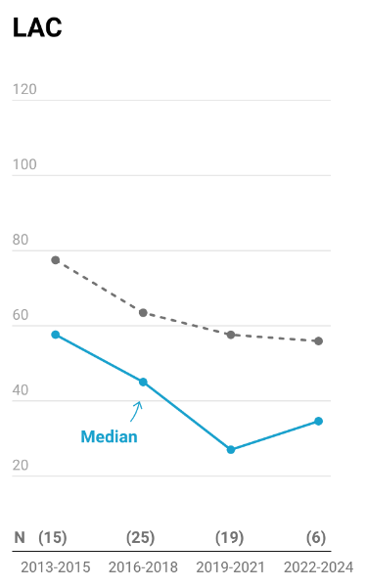 | 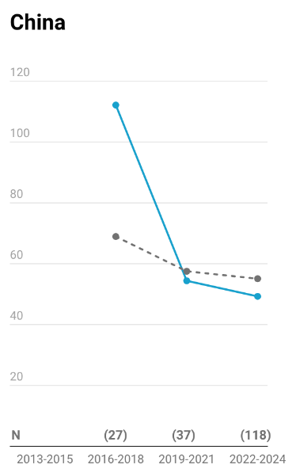
Source: Author’s elaboration based on data from BNEF (2025).
Note: The figure reports period medians of awarded auctions prices (USD/MWh) for a pooled PV + onshore wind “basket”, using completed auctions in the BNEF dataset from 2013 to 2024. The core sample excludes observations with missing prices and those prices below $1/MWh. The blue line shows the observed regional median for the basket. The gray dashed line is a global benchmark adjusted to the region’s PV/wind mix, where PV and wind weights are calculated using allocated capacity (MW) within each region–period. Specifically, the benchmark equals the region’s PV MW share times the global PV median (in that period) plus the region’s wind MW share times the global onshore wind median. This benchmark controls only for PV/wind composition and does not adjust for differences in contracting terms, auction design, market conditions, or country composition within regions.
Beyond the volume and technology profile of auction awards, we assess how central auctions have been to national power systems by comparing auction-awarded capacity to total installed capacity.
Of the 62 GW allocated in LAC, Brazil (7th) stands out as one of the world’s top ten markets, awarding 34 GW of capacity. Within LAC, Mexico (7.8 GW), Chile (7 GW), and Argentina (5.4 GW) also rank among the world’s top thirty markets in terms of auctioned capacity.
While the previous figures refer to absolute capacity allocated, a different picture emerges when we look at penetration—that is, auction-awarded capacity as a share of each country’s total installed capacity. Using data from IRENA (2025) for installed capacity by country, the top performers are the Netherlands (80.6%), Guinea-Bissau (66.7%), and Ireland (62.4%), where auctions account for well over half of the power system’s installed capacity. They are followed by Poland (49.5%), India (38.6%), the Philippines (35.0%), Germany (33.1%), the United Kingdom (33.0%), Albania (29.7%), Nepal (27.2%), and Morocco (24.2%). In these markets, competitive auctions have not only mobilized large volumes of clean capacity but have become a central mechanism shaping the structure of the power system itself. The first Latin American country to appear in this penetration ranking is Guatemala, in 15th place, where auction-awarded projects represent 21.8% of the country’s total installed capacity.
Explicitly state that this is not time-aligned.
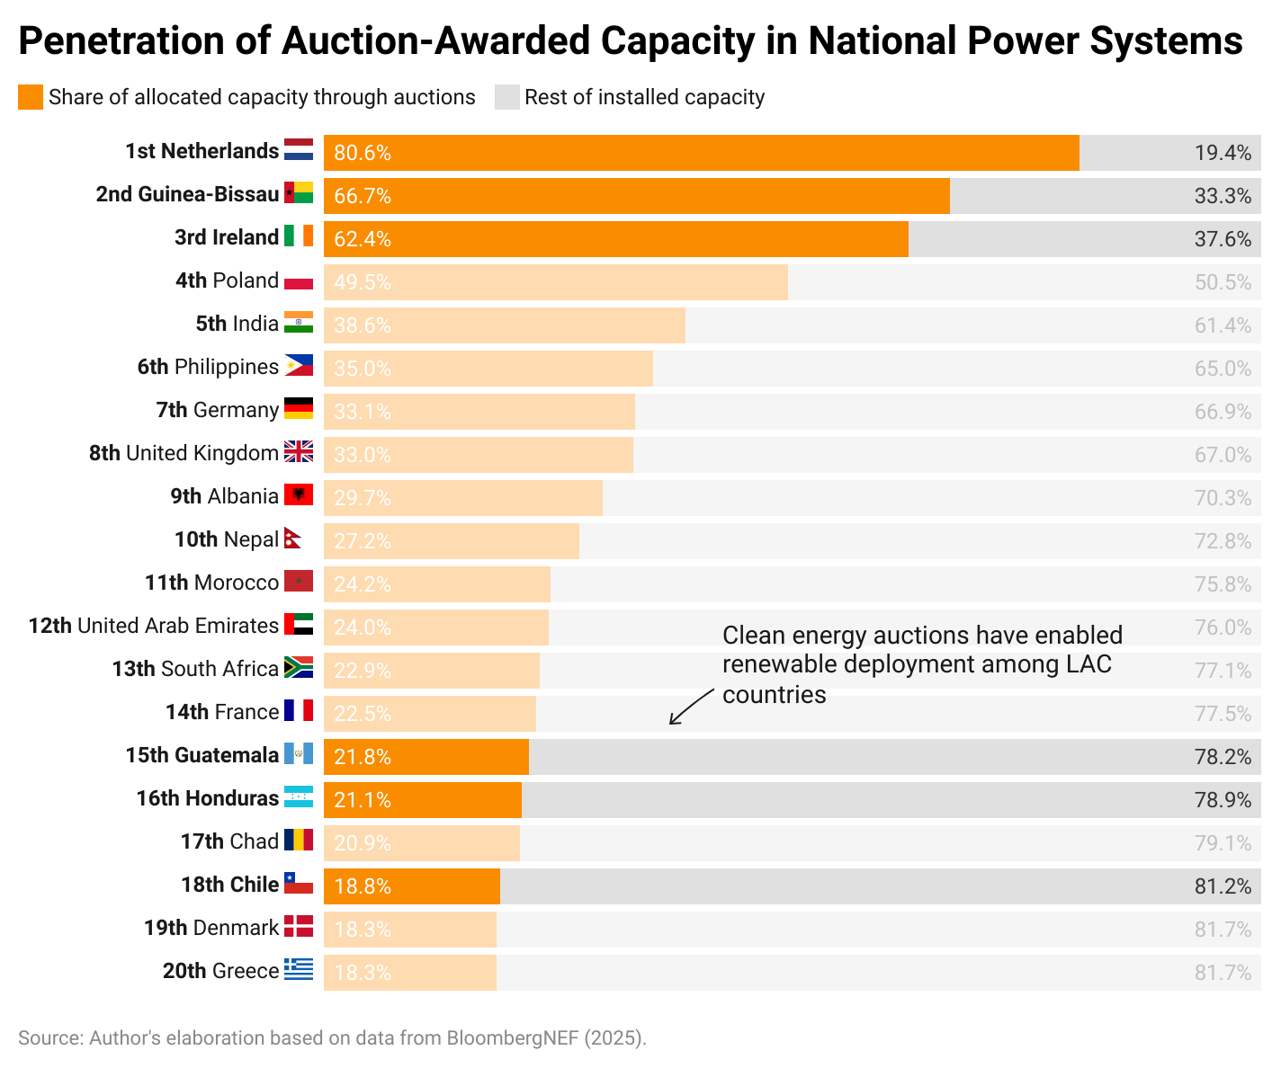

The region embraced auctions early on, recognizing them as a transparent way to attract private investment and reduce prices. In fact, some of the world’s first successful renewable tenders were held in Latin America – Brazil launched its inaugural alternative energy auctions in 2005, contracting wind, biomass and small hydro. Uruguay also ran wind energy tenders since 2006, pushing the deployment of wind energy (Source). BNEF registers that Brazil has held up to 2025 more than 80 auctions where renewable energy sources participated, allocating up to 34 GW of renewable capacity, mostly composed of wind (Figure X). Peru held the first renewable energy auctions in which solar technology could participate in 2009.
By 2017, at least 10 countries in the LAC region had implemented renewable auctions in some form, and today well over 15 countries have used this approach, including major markets like Mexico, Chile, Argentina, Peru, Colombia, and smaller ones like Guatemala, Honduras, Panama.
According to BNEF data, the first country to have a solar winning bid is Peru in 2010, where 80 MW were allocated with an average price of US$221 per MWh.
Auctions have awarded capacity equivalent to half of all wind, about one-fifth of solar PV and biomass/waste, but only a small fraction of hydro in LAC. In other words, auctions are the workhorse for newer renewables, but not legacy hydro.
The dataset contains 14 countries with completed auctions up to 2024 and actual allocated capacity data. Bolivia is present in the dataset yet has no values for capacity awarded. The allocated capacity via auctions in the region is 61.7 GW, this is roughly 12% of the 2024 total installed capacity in the region. Latin America and the Caribbean are slightly below the global average of 13.5% in terms of the share of installed capacity that has been allocated via auctions. Yet, auctions are still a major deployment channel in the region.
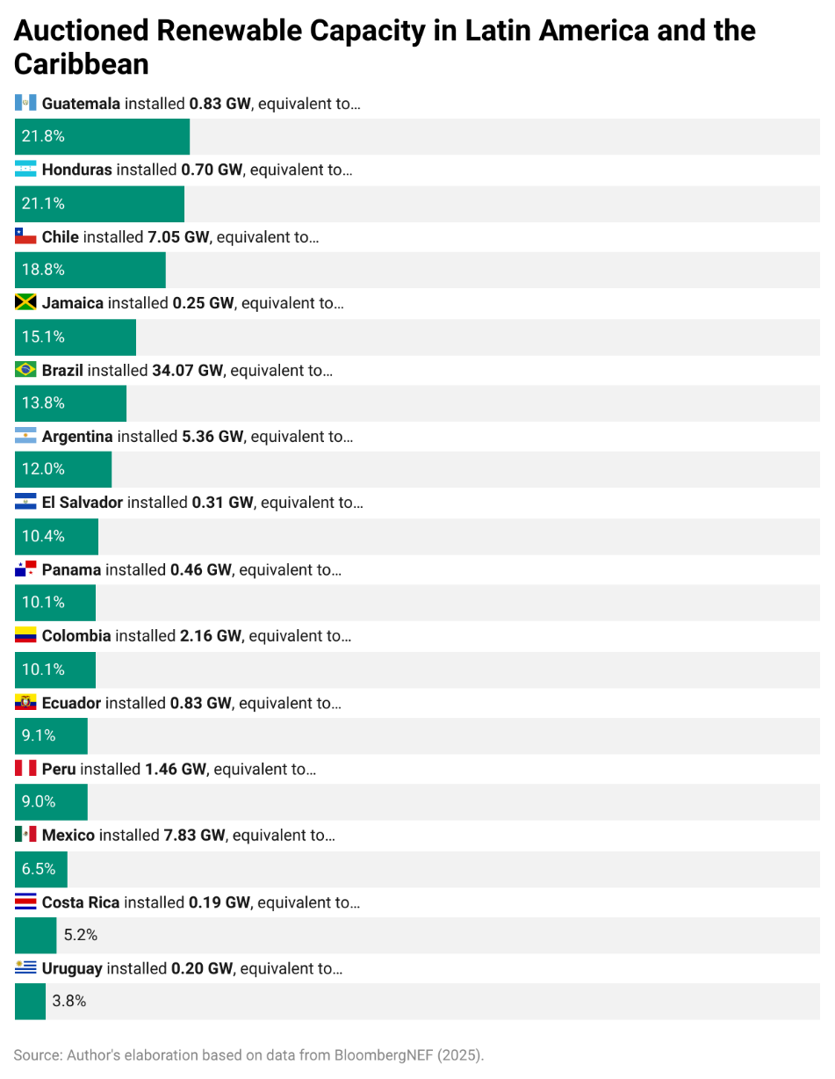
When compared to the existing renewable fleet…

Regional patterns differ from global patterns. Wind accounts for over 40% of the energy auctioned, followed by solar that accounts for almost 30%. Relative to the total installed capacity in the region, wind and solar awarded via auctions account for 8.5%.
When specific technologies’ capacity awarded through auctions is considered against its own existing installed capacity throughout the region, it is evident how this mechanism has been a key enabler
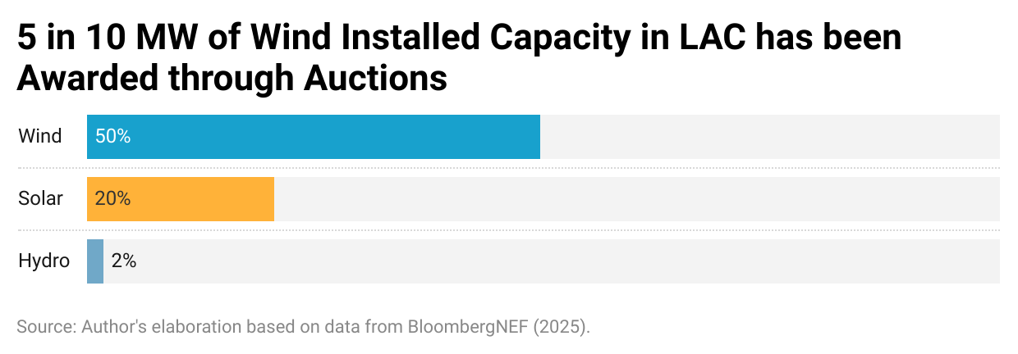

Country Case Studies: Auctions in Practice

Brazil
Brazil leads the way with 175 GW installed and an impressive 85% share of renewables. Wind and solar are expanding the fastest; Brazilian wind ranks 4th globally, generating 96 TWh in 2023, while solar ranks 6th with 52 TWh.
Brazil has the most extensive clean energy auction program in LAC. It pioneered auctions in 2005 to contract new capacity, initially focused on biomass and small hydro, and held its first wind-only auction in 2009, although there is a lag on the BNEF dataset. Since then, Brazil has held over 40 auctions where renewables were eligible, procuring a massive volume of power. These auctions have been the engine of Brazil’s renewable expansion: over 34 GW of renewable capacity was awarded from 2007 to 2023, spanning wind, solar, hydro, and biomass. This is about the entire installed capacity in Chile (34.8 GW) as of 2024.

Chile
Chile has already beaten all its renewable generation targets. It generates 70% of its electricity from renewable energy. The rapid growth has not been without issues. Chile’s long, thin grid faces severe transmission bottlenecks between the solar-rich north and population centers in the central/south. By 2020–2022, congestion led to frequent curtailment and even negative prices in parts of the grid, which dampened enthusiasm in recent auctions. Developers started factoring in transmission risk, and one auction in 2021 was under-subscribed. The Chilean government responded by promoting energy storage and grid investments. Chile is now a regional leader in batteries: by late 2023 it had 1.3 GW of storage operating and ~6.4 GW more planned. New auction rules also encourage projects that include storage to help meet evening demand. Additionally, Chile is investing ~$2 billion to upgrade transmission by 2026. These steps are aimed at sustaining renewable growth despite the grid constraints.
Chile stands out for its market-based, technology-neutral auction system that has successfully incorporated renewables. Since 2006, Chile’s regulated utilities (distribution companies) have run annual power supply auctions to buy energy for customers. These tenders do not mandate specific technologies; any generation source can bid to supply blocks of power. To ensure renewables aren’t disadvantaged by their intermittency, Chile implemented innovative intraday time blocks: bidders offer energy in time slices (e.g. daytime vs nighttime). This design allowed solar PV to compete in daytime blocks and wind or other sources in evening blocks, mitigating the issue of variable output. In the mid-2010s renewables were winning the bulk of Chile’s auctioned demand.
Chile’s auctions contracted large volumes of renewables at low cost. A landmark moment was the 2016 auction, where renewables won the whole 12.3 TWh/yr on offer—displacing coal and gas offers—at an average price of just $47/MWh, which was 75% lower than prices in 2013. To illustrate, this is around the electricity generated throughout 2024 in electricity systems like Bolivia (12.4 TWh), Costa Rica (12.6 TWh), or Honduras (12.7 TWh).

References
Anatolitis, V., Azanbayev, A. and Fleck, A.K. (2022). How to design efficient renewable energy auctions? Empirical insights from Europe. Energy Policy 166, 112982. https://doi.org/10.1016/j.enpol.2022.112982
Bagnoli, L., Balza, L.H., Belmar, J. and Matías, D. (2025). Powering Through Drought: The Impact of Water Scarcity on Electricity Generation. Working Paper No. IDB-WP-1785, Inter-American Development Bank, Infrastructure and Energy Sector.
BloombergNEF (2024). Latin America’s Clean Energy Build to Peak in 2024. Available at: https://about.bnef.com/insights/clean-energy/latin-americas-clean-energy-build-to-peak-in-2024/ (Accessed 9 January 2026).
Climate Policy Hub (2023). Renewable Energy Auctions in Brazil. Available at: https://www.climatepolicyhub.com/renewable-energy-auctions-brazil (Accessed 9 January 2026).
Del Río, P. (2017). Designing auctions for renewable electricity support: Best practices from around the world. Energy for Sustainable Development 41, 1–13. https://doi.org/10.1016/j.esd.2017.05.006
Eberhard, A. and Kruger, W. (eds.) (2023). Renewable Energy Auctions: Lessons from the Global South. Oxford University Press. https://doi.org/10.1093/oso/9780192871701.001.0001
Fleck, A.K., and Anatolitis, V. (2023). Insights from renewable energy auction design in Europe. Energy Policy 170, 113357. https://doi.org/10.1016/j.enpol.2022.113357
Haufe, M.-C. and Ehrhart, K.-M. (2018). Auctions for renewable energy support – suitability, design, and first lessons learned. Energy Policy 121, 217–224. https://doi.org/10.1016/j.enpol.2018.06.027
Hochberg, M. (2018). Renewable Auction Design in Theory and Practice: Lessons from the Experiences of Brazil and Mexico. OIES Paper EL 28, Oxford Institute for Energy Studies.
IDB (2013). Latin America and the Caribbean could cover all their electricity needs using renewable resources: IDB report. Inter-American Development Bank.
IDB (2022). The Energy Path of Latin America and the Caribbean. Inter-American Development Bank.
IEA (2021). Climate Impacts on Latin America Hydropower. International Energy Agency.
IEA (2023). Latin America Energy Outlook 2023. International Energy Agency.
IEA (2024a). Integrating Solar and Wind. International Energy Agency.
IEA (2024b). Reducing the Cost of Capital: Strategies to Unlock Clean Energy Investment in Emerging and Developing Economies. World Energy Investment Special Report, International Energy Agency.
IEA (2025). Renewables 2025: Analysis and Forecasts to 2030. International Energy Agency.
IRENA (2013). Renewable Energy Auctions in Developing Countries. International Renewable Energy Agency.
IRENA (2015). Renewable Energy Auctions A Guide To Design. International Renewable Energy Agency.
IRENA (2019). Renewable Energy Auctions Status and Trends Beyond Price. International Renewable Energy Agency.
IRENA (2026). Renewable energy auctions: Design for risk allocation. International Renewable Energy Agency.
Knight, R.R., Lukas, J.J., Fulp, T.J., Gangopadhyay, S. and Trumbo, B.A. (2020). Multiyear droughts and pluvials over the Upper Colorado River Basin: A paleohydrologic modeling perspective. Water Resources Research 56(3), e2019WR025676.
OLADE (2021). Procesos competitivos para el financiamiento de proyectos de energías renovables en ALC. Organización Latinoamericana de Energía (OLADE).
Ritchie, H. (2021). The price of batteries has declined by 97% in the last three decades. Published online at OurWorldinData.org. Retrieved from: https://archive.ourworldindata.org/20251125-173858/battery-price-decline.html
Roberts, D. (2020). Feed-in tariffs for renewable power and the role of auctions: the Chinese & global experience. China Economic Journal 13(2), 152–168. doi:10.1080/17538963.2020.1752494.
Thapar, S., Sharma, S. and Verma, A. (2018). Analyzing solar auctions in India: Identifying key determinants. Energy for Sustainable Development 45, 66–78. https://doi.org/10.1016/j.esd.2018.05.003
The Oxford Institute for Energy Studies. (2018). Renewable Auction Design in Theory and Practice: Lessons from the Experiences of Brazil and Mexico. Oxford
Viscidi, L. and Yépez, A. (2019). Clean Energy Auctions in Latin America. Report, Inter-American Development Bank.
Zhang, M., Guo, Q., Liu, L. and Zhou, D. (2025). Renewable energy investment under the market-oriented transition of policies. Energy Policy 204, 114683. https://doi.org/10.1016/j.enpol.2025.114683
Figure X
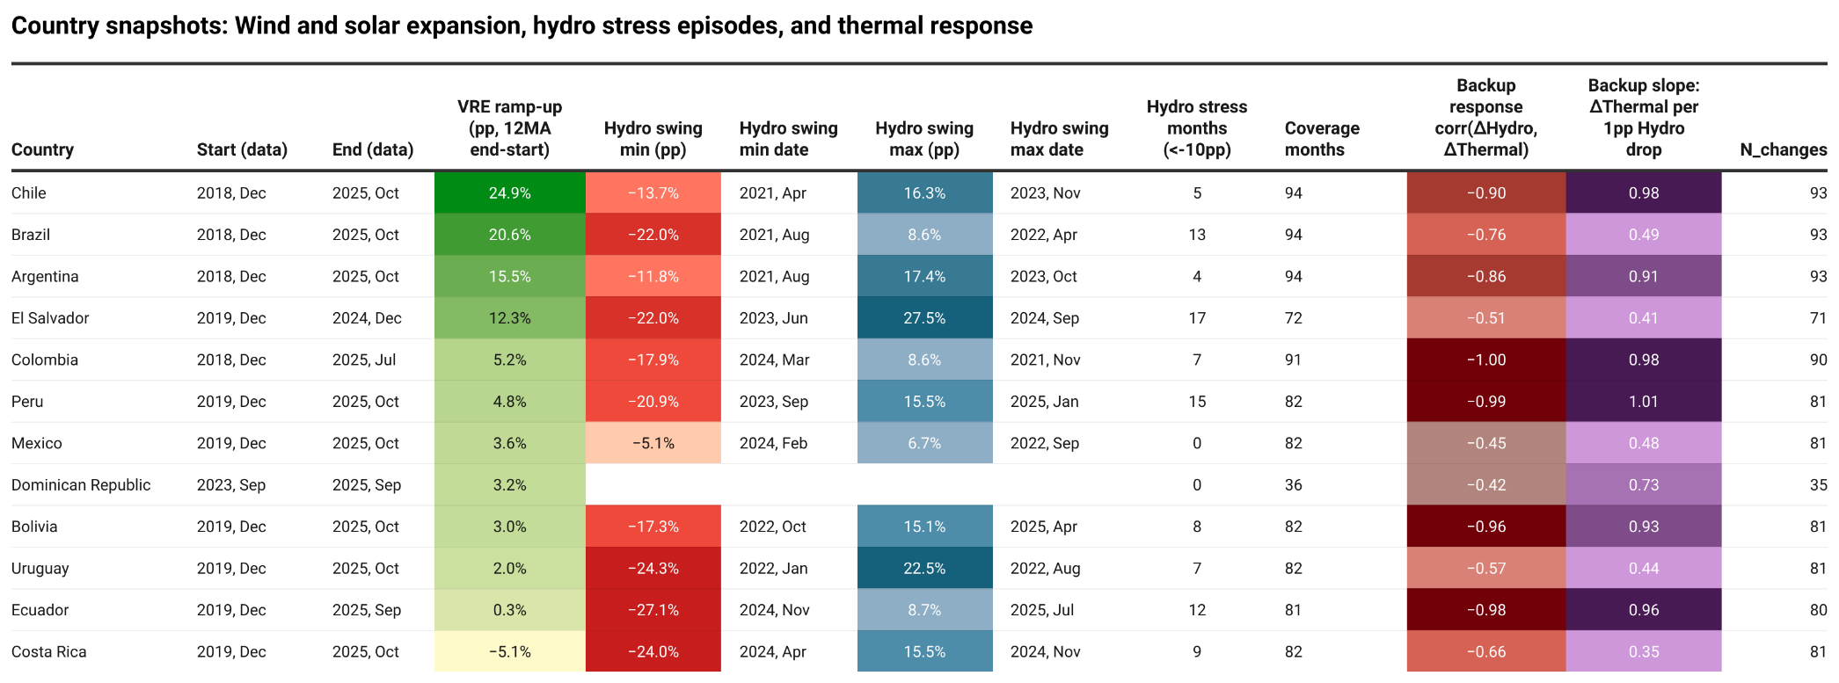
Source: Author’s elaboration based on data from EMBER (2025).

The BNEF extract is recorded at the auction-result level (rows). A single auction round can appear multiple times when it awards capacity across multiple technologies or subsectors. In this note, “ number of auctions” refers to unique auctions rounds, defined as Auction program and round + Market + Auction year. Under this definition, the dataset includes 1,817 completed rounds over 2004-2024 (versus 1,864 result entries/rows).

